

**WEB-BASED INTERFACE DESIGN**

**(CSF3133)**

**Lab Report 1**

Name: Fatin Nurain binti Alham

Matric: S75855

Date: 22 October 2025

Group: K4

Programme: Bachelor of Computer Science (Software Engineering) With Honors

Course Lecture: Assoc.Prof.Ts.Dr.Wan Nural Jawahir

Lab Moderator: Miss Wan Fatin Fatihah binti Yahya

**1.4 Structure of an HTML Document**

Output:

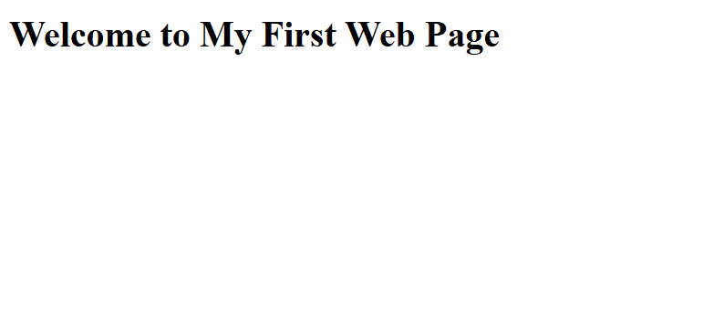

**1.5 Basic HTML Tags**

**1.5.1 Headings**

Output:

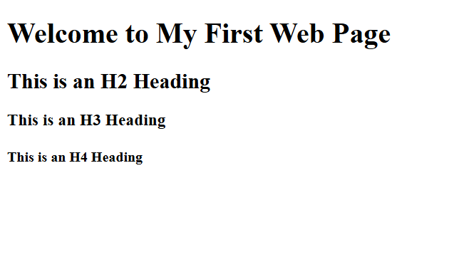

**1.5.2 Paragraphs and Text Formatting**

Output:

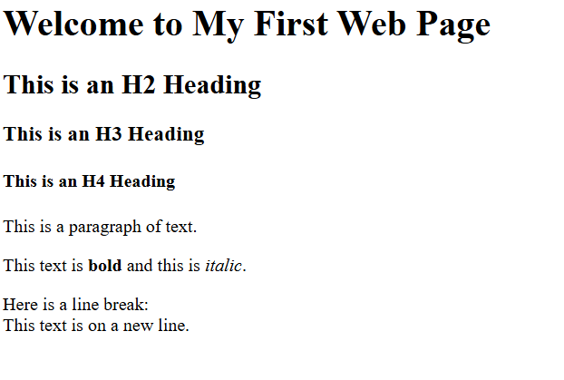

**1.5.3 Lists (Ordered and Unordered)**

Output:

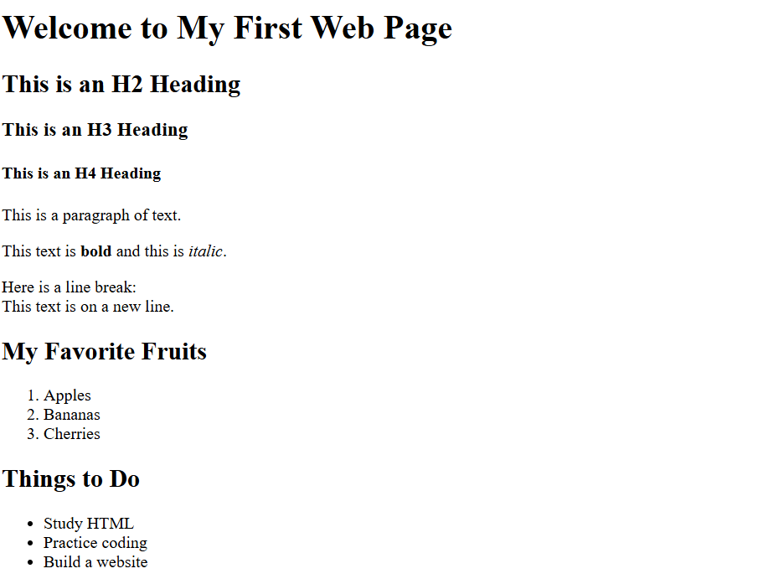

**1.6 Links and Images**

**1.6.1 Add a Hyperlink**

Output:

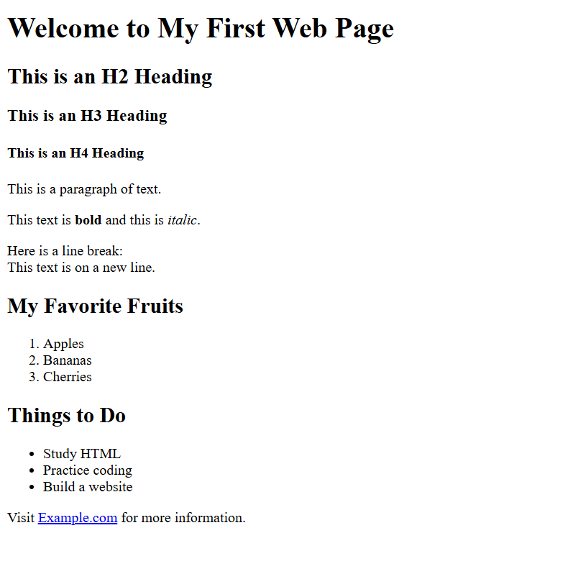

**1.6.2 Insert an Image**

Output:

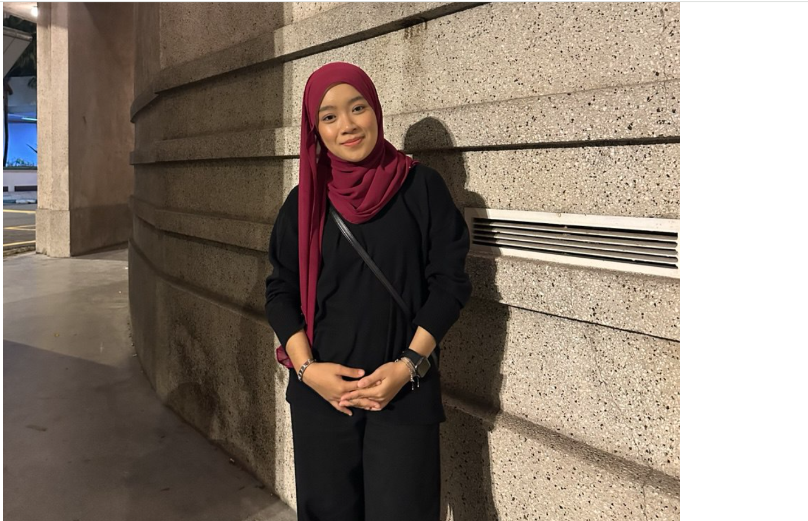

**1.7 Lab Exercise 1**

**1.7.1 Designing Simple Personal Webpage**

Output:

1. TITLE



1. HEADING

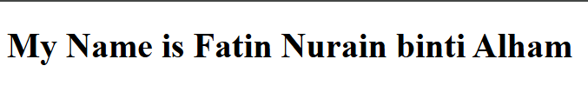

1. SHORT PARAGRAPH ABOUT HOBBIES



1. FAVOURITE MOVIES

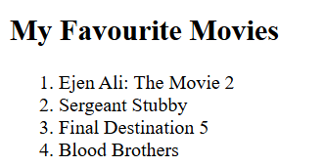

1. TOP 3 FAVOURITE HOBBIES

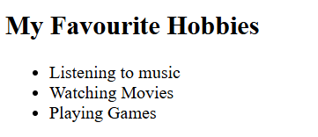

1. LINK TO RELEVANT WEBSITE



1. IMAGES



